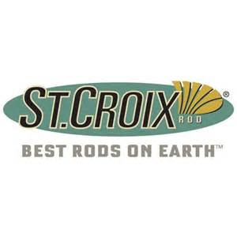
Central Montana Perch Derby
Eastfork Reservoir
January 21st 2017
8:00am to 2:00pm
Come join the fun. Lots of prizes and 100% payout
$40.00 per Team (100 team Limit)
$10.00 Big Perch Pot with 100% payback (3 places)
Mandatory rules meeting starts at 7:30am morning of the tournament
Applications and Rules available at Dons Store, The Sports Center, Lewistown Sports and online at
montanawalleyesunlimited.net or Crooked Creek Facebook page.

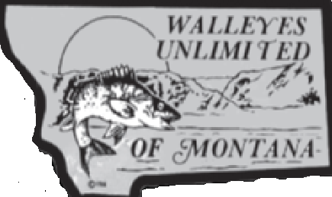
Crooked Creek Chapter
For more info Contact :
Kennie Williams at 406-670-0885

